Report on Anneal

**Step1: Performing initial EDA:**

In metallurgy and materials science, annealing is a heat treatment that alters the physical and sometimes chemical properties of a material to increase its ductility and reduce its hardness, making it more workable. It involves heating a material above its recrystallization temperature, maintaining a suitable temperature for a suitable amount of time, and then allow slow cooling.

* First I have downloaded my dataset and opened my dataset when I see the dataset there are many question marks I have removed those question marks and replaced with the blank cells and used forward filling.
* After filling all those now I have imported the dataset in python
* I have done data.shape it gives the number of columns and rows in dataset. There are 39 columns and 898 columns.
* Next I have done the value.counts to each and every columns to check the what column we need to change to 1,2,3……
* Now after doing that we can true and false to 0 and 1.
* After doing this we need to check the variance of the columns for we use the code df.var()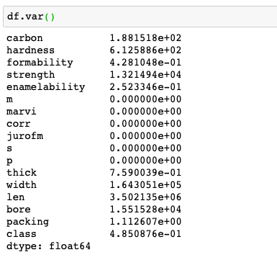
* We can see that variance is high in the Hardness.
* Next doing the label encoding by using the mini max scaler.

**Step2: Perform classification:**

* Performed a logistic regression
* Data is splitted into training and test data.
* Now the trained data is done on the test data
* After doing that I got the as 78% as accuracy
* Performed a classification using multi-layer neural network model by code:(from sklearn.neural_network import MLPClassifier, from sklearn.metrics import accuracy_score) and taken hidden layers size is 150,99 respectively and I got the accuracy of 78.4% accuracy. There is no increase in the accuracy.
* Tried using the with the layers I got 77%.
* Next I have used the SVM I got accuracy of 78% still no change.
* Finally I have used the Random Forest I have got the accuracy of 100%.